Guide Name |  | Panel Head
 | Dr Sumathy G | Dr Sumathy G
 | Faculty Name | Project Domain
 | Dr Sumathy G | SDG – 4 Quality Education
 |  | Passport size photo(s)
 | - RA2211047010134 | 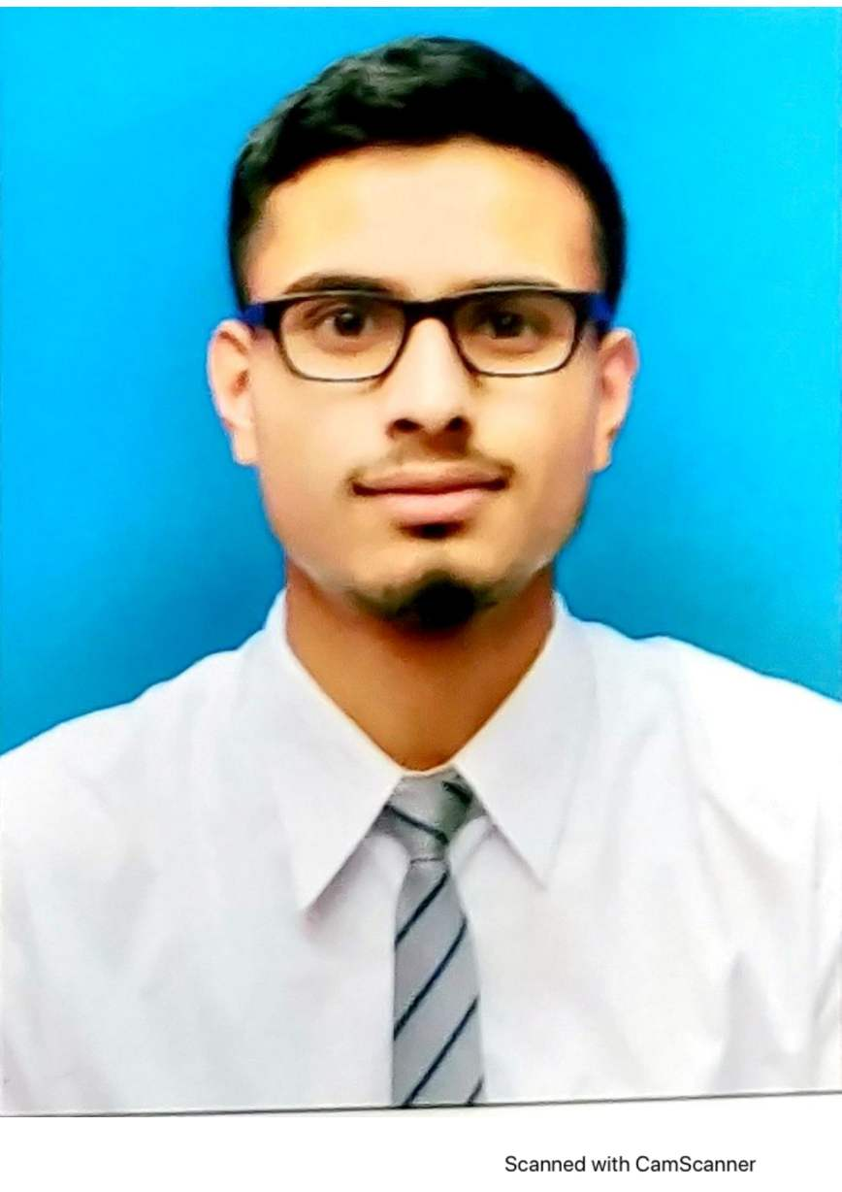  
 | - RA2211047010116
Visionary Career Assistance

Registration Number(s)

1. Atharv Dobhal
2. Hari Venkataraman

Email ID(s)&Mobile Number(s)
1: ad6801@srmist.edu.in (9456179625) | 2: hv9961@srmist.edu.in (8148473998)
Abstract Architecture Diagram
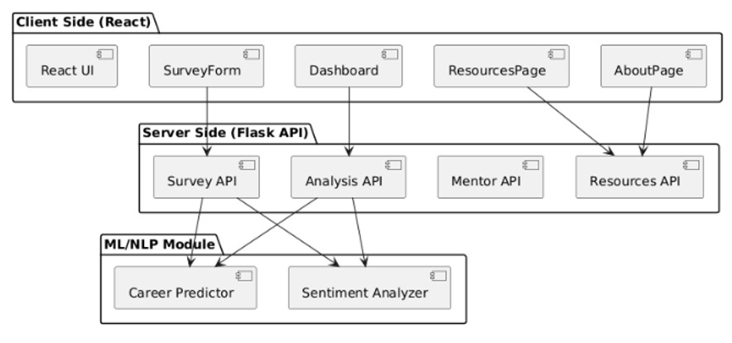
Visionary Career Assistance combines frontend and backend components to create a comprehensive career guidance solution. The platform features two main components: a Data-Driven Analysis Dashboard and a Mentor Connections Platform. The dashboard evaluates role model impacts, student backgrounds, behavioural trends, and income distribution to identify critical factors affecting career choices. The mentorship component connects students with experienced professionals, allowing them to explore detailed mentor profiles and receive personalized guidance tailored to their unique circumstances

Significance of the Project Conclusion
Visionary Career Assistance bridges equity gaps in career guidance by combining data analytics with human mentorship. The platform democratizes access to quality career resources, particularly benefiting underserved communities through mobile-responsive design. Its hybrid approach delivers personalized insights through role model analysis, socioeconomic background assessment, and behavioural tracking, while connecting students with verified professionals. The platform directly contributes to SDGs 4, 8 and 10 by improving education access, promoting employment readiness, and reducing inequality in career development opportunities.
Visionary Career Assistance successfully delivers a comprehensive career guidance platform that combines data analytics with human mentorship. The dual-component system-featuring a Data-Driven Analysis Dashboard and Mentor Connections Platform-empowers students from all backgrounds to make informed career decisions. By analysing role model influences, socioeconomic factors, and behavioural patterns while connecting students with industry professionals, the platform democratizes access to quality guidance resources. This contributes to SDGs 4, 8, and 10 by promoting educational equity, employment readiness, and reduced inequality. The mobile-responsive design ensures accessibility, supporting the project's mission of inclusive career development.

Conference/Journal Publication Details (Mandatory)

